Structural Design Pattern
According to Wikipedia, in software engineering, Structural Design Patterns in Java are Design Patterns that ease the design by identifying a simple way to realize the relationship among entities. In simple words, we can say that the Structural Design Pattern is basically used to manage the structure of classes and interface as well as manage the relationship between the classes. These Design Patterns work with class and object composition and use inheritance to write interfaces and obtain new functionality.
When to use Structural Design Patterns in Java?
In real-time applications, sometimes we need to change the structure of a class or the relationship among the classes but we don’t want this change to be affected by the project. For example, if we have two classes let’s say User and Product. And the Product class is used inside the User class making one-to-many relationships between the User and Product. Tomorrow, the structure or the relationships between these two classes change. The customer now wants to keep away the Product class from the User class, as they want to use the User and Product class independently. This is actually a structural change and we don’t want this structural change to affect our project. This is where the Structural Design Pattern helps us.

The following patterns are included under structural design patterns:
- Adapter Pattern: This pattern connects two incompatible interfaces by providing a wrapper for a class or object that uses a different interface, allowing it to be used with another interface.
- Bridge Pattern: This pattern separates an abstraction from its implementation so that it can change independently. It achieves this by separating the interface from the implementation without using inheritance.
- Composite Pattern: This pattern organizes objects into tree structures to represent part-whole hierarchies and allows clients to treat individual objects and compositions of objects in the same way.
- Decorator Pattern: This pattern adds new functionality to an existing object without changing its structure by wrapping it with additional functionality.
- Facade Pattern: This pattern simplifies access to a complex subsystem by providing a simplified interface that hides the complexities of the system.
- Flyweight Pattern: This pattern minimizes memory usage by sharing as much data as possible with other similar objects, reducing the number of objects created.
- Proxy Pattern: This pattern controls access to another object by providing a surrogate or placeholder for it. It creates an intermediary that acts as an interface to another resource.

What is Adapter Design Pattern?
In software development, it is common to encounter situations where existing classes or components have incompatible interfaces. The Adapter design pattern provides a solution by allowing objects with incompatible interfaces to work together seamlessly. By creating an adapter class that acts as an intermediary, the pattern enables collaboration between incompatible interfaces without modifying their underlying implementations.
That means the Adapter Design Pattern allows incompatible interfaces (objects) to work together. The Adapter Pattern acts as a bridge between two incompatible objects. Let’s say the first object is ABC and the second object is XYZ. And object ABC wants to consume some of the services provided by object XYZ. As these two objects are incompatible, they cannot communicate directly. In this case, Adapter will come into the picture and will act as a middleman or bridge between object ABC and object ZYZ. Now, object ABC will call the Adapter and Adapter will do the necessary transformations or conversions and then it will call object XYZ. So, Adapter which is a class is responsible for communication between two independent or incompatible interfaces.
The Adapter design pattern is a structural pattern that allows objects with incompatible interfaces to work together. It involves the following components:
- Target: Defines the interface that the client code expects to interact with.
- Adaptee: Represents the existing class or component with an incompatible interface that needs to be adapted.
- Adapter: Acts as an intermediary between the client and the adaptee, implementing the target interface and delegating requests to the adaptee.
Example to Understand Adapter Design Pattern in Java
Let’s consider a real-world example where the Adapter pattern can be applied: connecting a new smartphone to an older audio system. In this scenario, the audio system has a traditional 3.5mm audio jack, while the smartphone only has a USB-C port. The Adapter pattern can be used to bridge the incompatibility and allow the smartphone to connect and play audio through the audio system.
The Adapter class will act as an intermediary between the smartphone and the audio system. It will implement the expected interface of the audio system and internally handle the conversion or translation of USB-C signals to the audio system’s requirements. The Adapter will have the necessary logic to convert the digital audio signal from the smartphone into an analog signal that the audio system can understand.
By using the Adapter pattern, the smartphone can seamlessly connect to the audio system without requiring any modifications to the audio system’s existing code or hardware. The Adapter acts as a translator, ensuring compatibility between the two systems and enabling them to work together. The UML Diagram of this example is given below using Adapter Design Pattern.
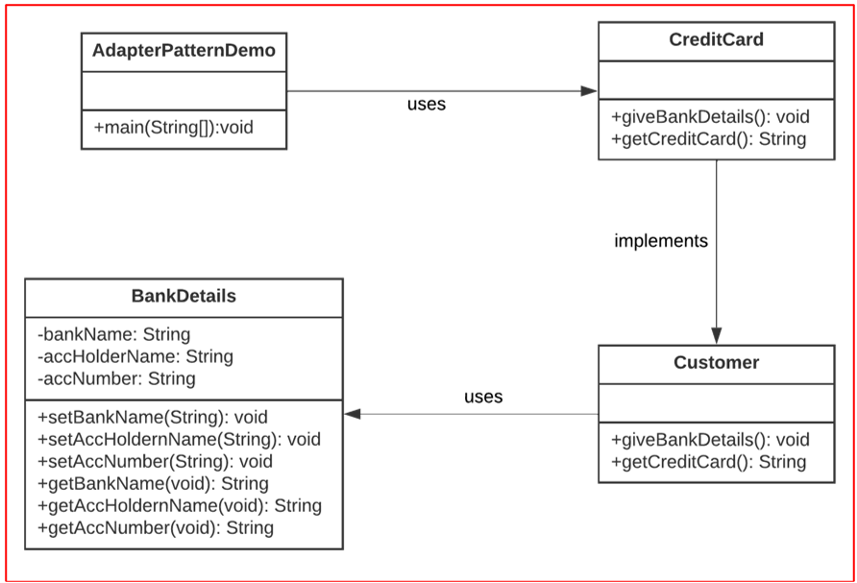
Implementing Adapter Design Pattern in Java
Step 1: Create a new directory to store all the class files of this project.
Step 2: Open VS Code and create a new project, called adapter.
Step 3: In the project, create a new file called CreditCard.java. Add the following code to the file:
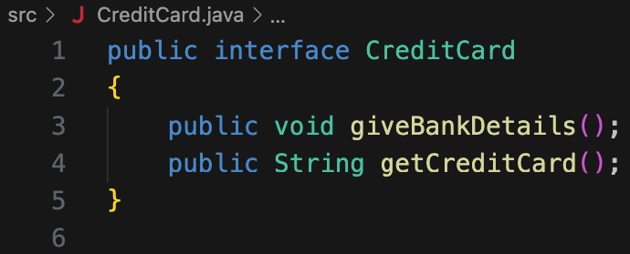
Step 4: In the project, create a new file called BankDetails.java. Add the following code to the file:
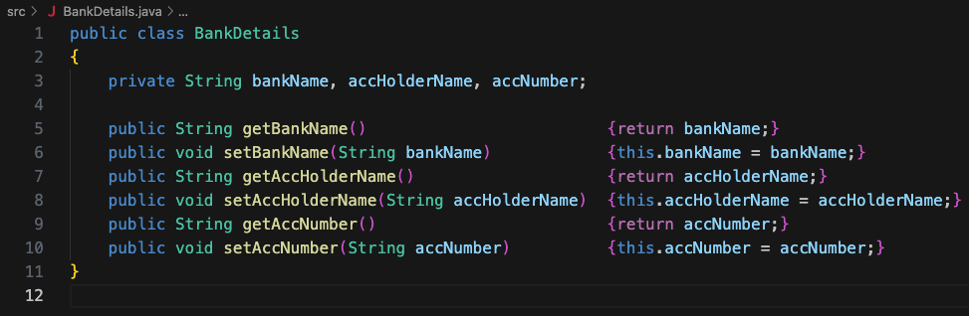
The setters and getters can easily be added by following these steps (this works for VS Code only; other IDEs usually have some similar option):
- Add the fields to the class.
- Right-click in the editor and select the “Source Action…” button.
- In the menu that appears, select the “Generate Getters and Setters…” option.
- In the drop-down menu that appears, select all three of the variables.
Step 5: In the project, create a new file called Customer.java. Add the following code to the file:
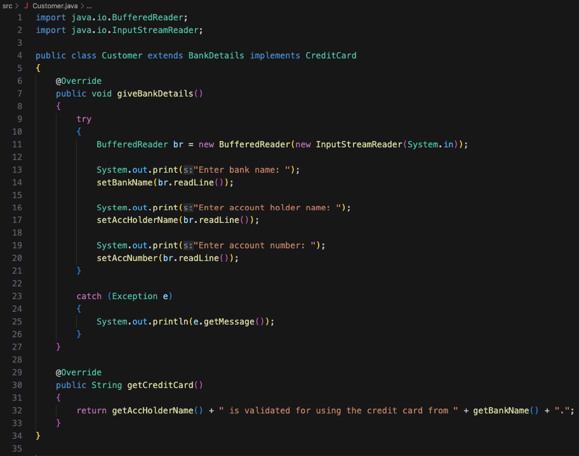
This class extends from BankDetails and implements the CreditCard interface. It implements the abstract methods from the CreditCard interface. It also uses the methods from the BankDetails class.
Step 6: In the project, create a new file called AdapterPatternDemo.java. This file will contain the main() function. Add the following code to the file:
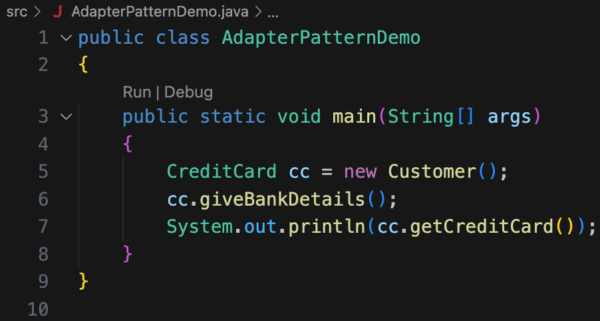
This function creates a new object of type CreditCard. Then, it executes the two functions from the credit card interface (which were implemented in the Customer class).
Step 7: Compile and execute the application. Ensure compilation is successful. Verify that the program works as expected.
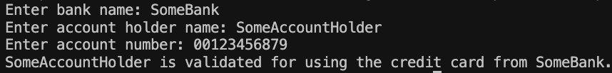
Congratulations! You now know how to implement adapter patterns!
UML Diagram of Adapter Design Pattern:
Now, let us see the Adapter Design Pattern UML Diagram Components with our Example so that you can easily understand the UML Diagram.
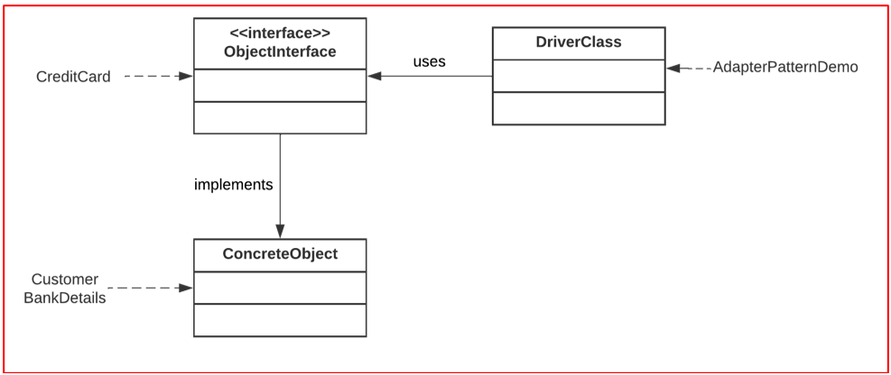
The classes can be described as follows:
- ObjectInterface: This is the interface that concrete classes can implement.
- ConcreteObject: This object implements the aforementioned interface.
- DriverClass: This class contains the main() function. It is responsible for handling the application simulation.
The Complete Example Code of Adapter Design Pattern in Java
AdapterPatternDemo.java
public class AdapterPatternDemo
{
public static void main(String[] args)
{
CreditCard cc = new Customer();
cc.giveBankDetails();
System.out.println(cc.getCreditCard());
}
}
BankDetails.java
public class BankDetails
{
private String bankName, accHolderName, accNumber;
public String getBankName() {return bankName;}
public void setBankName(String bankName) {this.bankName = bankName;}
public String getAccHolderName() {return accHolderName;}
public void setAccHolderName(String accHolderName) {this.accHolderName = accHolderName;}
public String getAccNumber() {return accNumber;}
public void setAccNumber(String accNumber) {this.accNumber = accNumber;}
}
CreditCard.java
public interface CreditCard
{
public void giveBankDetails();
public String getCreditCard();
}
Customer.java
import java.io.BufferedReader;
import java.io.InputStreamReader;
public class Customer extends BankDetails implements CreditCard
{
@Override
public void giveBankDetails()
{
try
{
BufferedReader br = new BufferedReader(new InputStreamReader(System.in));
System.out.print("Enter bank name: ");
setBankName(br.readLine());
System.out.print("Enter account holder name: ");
setAccHolderName(br.readLine());
System.out.print("Enter account number: ");
setAccNumber(br.readLine());
}
catch (Exception e)
{
System.out.println(e.getMessage());
}
}
@Override
public String getCreditCard()
{
return getAccHolderName() + " is validated for using the credit card from " + getBankName() + ".";
}
}

- Code Reuse: The Adapter pattern promotes code reuse by allowing the integration of existing classes or components into new systems without requiring significant modifications. Adapters encapsulate the necessary translations or mappings between interfaces, enabling the reuse of legacy code in modern systems.
- Interoperability: The Adapter pattern facilitates interoperability by bridging incompatible interfaces. It allows components developed independently or by different teams to collaborate seamlessly, reducing the impact of interface incompatibilities and fostering system integration.
- System Extensibility: The Adapter pattern enhances system extensibility by providing a flexible mechanism to incorporate new functionality. New adapters can be developed to integrate additional components or services without modifying existing code, minimizing the risk of introducing regressions or breaking existing functionality.
- Separation of Concerns: Adapters promote the separation of concerns by isolating the logic required for interface translation. This separation allows for cleaner and more modular code, as each adapter focuses on a specific translation or adaptation task.
- Legacy System Integration: The Adapter pattern is particularly useful when integrating legacy systems into modern architectures. Adapters can bridge the gap between legacy components and modern interfaces, allowing for a gradual migration and minimizing disruptions to the existing system.
Disadvantages of Adapter Design Pattern in Java
Some of the disadvantages of using the adapter design pattern are:
- Increased Complexity: The Adapter pattern introduces additional complexity to the codebase. Adapters may need to handle multiple translation scenarios, and the mapping between incompatible interfaces can become intricate. This complexity can impact code readability and maintainability.
- Performance Overhead: Adapters may introduce a performance overhead due to the translation and mapping operations required. These additional operations can impact system performance, especially in high-performance or time-critical scenarios. Careful consideration should be given to performance optimizations when using adapters.
- Potential Overuse: Overusing the Adapter pattern can lead to a bloated codebase with an excessive number of adapters. It is important to strike a balance and use the Adapter pattern judiciously when there is a genuine need to bridge incompatible interfaces.
- Implicit Dependency: Adapters may introduce implicit dependencies between the client code and the adaptee. This can hinder the ability to replace or switch adaptees without affecting the client code. Care should be taken to minimize tight coupling between adapters and clients.
- Debugging and Troubleshooting: When issues arise, debugging and troubleshooting can become more challenging due to the presence of adapters. The complexity introduced by adapters may require additional effort to trace and identify problems, especially when multiple adapters are involved in the system.

Real-Time Example of Bridge Design Pattern in Java:
Please have a look at the following image for a better understanding of the Bridge Design Pattern. On the left-hand side, you can see the Abstraction. Suppose, you want to turn on the TV or turn off the TV, then what you can do here is, you can use the Remote Control to turn On/Off the TV. The Implementation will be done by the original TV implementer. So, in this case, Samsung TV or Sony TV will implement the turn On or turn Off functionality. So, the abstraction will use one of the implementers to turn on or turn off the TV.
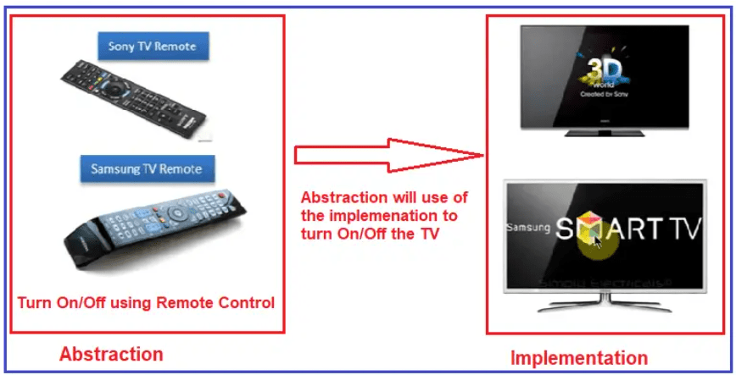
Suppose, later you want to add a new implementation then you can do this in the Implementation Layer. For example, you can add new TV (for example Panasonic TV) in the Implementation Layer which will not affect the Abstraction Layer. You can also add a new Panasonic TV Remote Control in the Abstraction Layer without affecting the Implementation Layer. So, this is one of the best examples of the Bridge Design Pattern.
Example to Understand Bridge Design Pattern in Java
The bridge pattern can be used to design a system to manage the students of a particular school. This allows us to make the code more modular. It also makes it easier to add/update/delete students. The UML Diagram of this example is given below using Bridge Design Pattern.
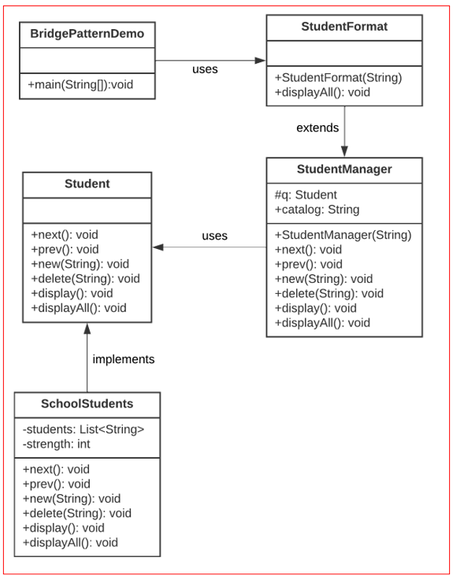
Implementing Bridge Design Pattern in Java
Step 1: Create a new directory to store all the class files of this project.
Step 2: Open VS Code and create a new project, called bridge.
Step 3: In the project, create a new file called Student.java. Add the following code to the file:
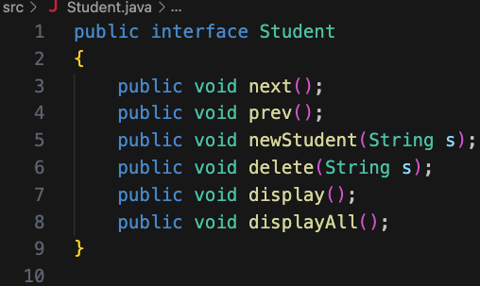
Step 4: In the project, create a new file called SchoolStudents.java.
Step 5: Import the following packages into SchoolStudents.java:
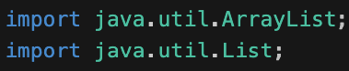
Step 6: Define the following fields in the class:
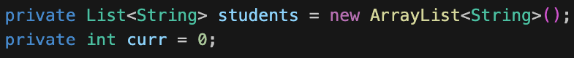
Step 7: Add a constructor that initializes the list of students:
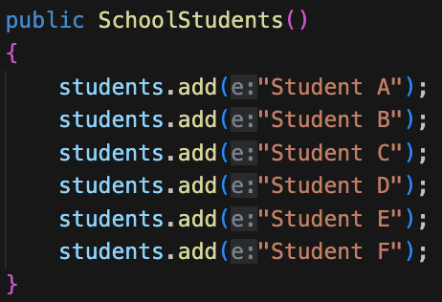
Step 8: Implement the next() and prev() functions. These functions were defined in the Student interface. These will be implemented in this class:
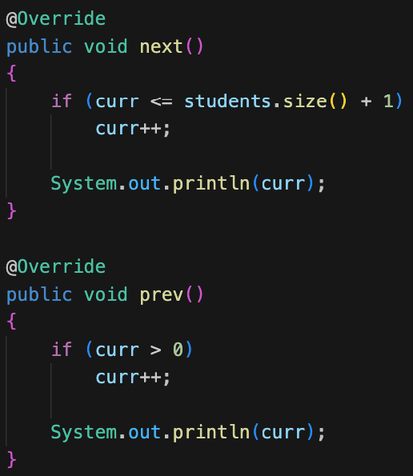
Step 9: Implement the other functions (which were defined in the interface) as well:
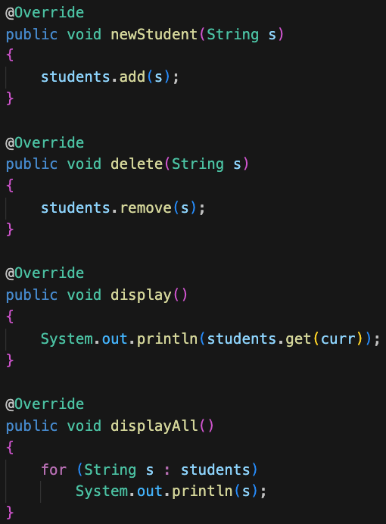
Step 10: In the project, create a new file called StudentManager.java. Add the following code to the file:
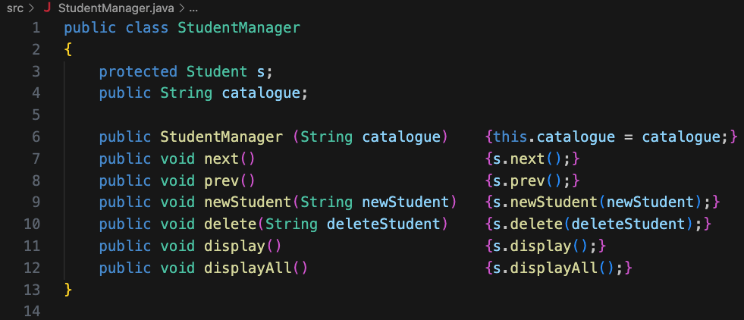
Step 11: In the project, create a new file called StudentFormat.java. Add the following code to the file:
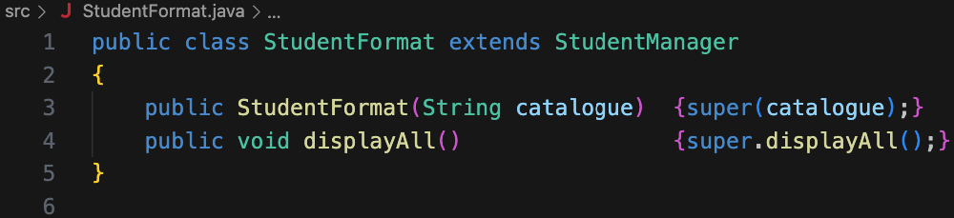
Step 12: In the project, create a new file called BridgePatternDemo.java. This file will contain the main() function. Add the following code to the file:
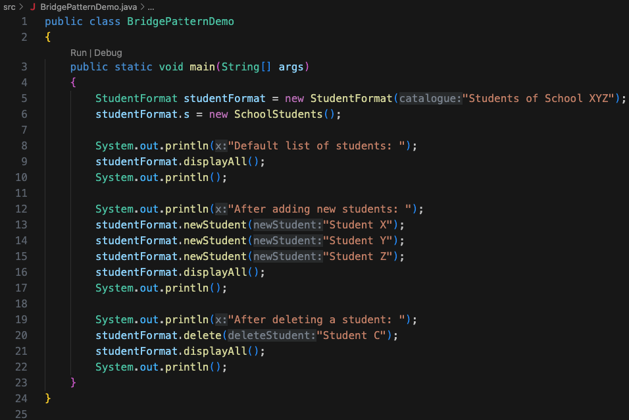
Step 13: Compile and execute the application. Ensure compilation is successful. Verify that the program works as expected.
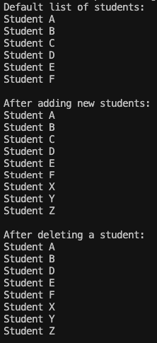
Congratulations! You now know how to implement bridge patterns!
UML Diagram of Bridge Design Pattern:
Now, let us see the Bridge Design Pattern UML Diagram Components with our Example so that you can easily understand the UML Diagram.
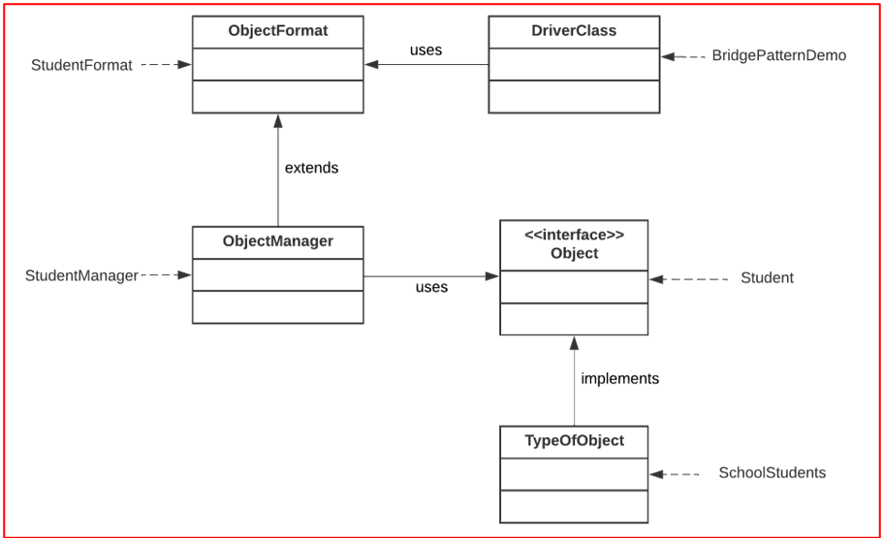
The classes can be described as follows:
- ObjectFormat: This class is used to format the object.
- ObjectManager: This class is used to handle the object operations, such as add, delete, update, etc.
- Object: This interface defines the functions that must be supported by the object. The implementation of these function need to be defined in another class (which implements this class)
- TypeOfObject: This class implements the Object interface and all its functions.
The Complete Example Code of Bridge Design Pattern using Java
BridgePatternDemo.java
public class BridgePatternDemo
{
public static void main(String[] args)
{
StudentFormat studentFormat = new StudentFormat("Students of School XYZ");
studentFormat.s = new SchoolStudents();
System.out.println("Default list of students: ");
studentFormat.displayAll();
System.out.println();
System.out.println("After adding new students: ");
studentFormat.newStudent("Student X");
studentFormat.newStudent("Student Y");
studentFormat.newStudent("Student Z");
studentFormat.displayAll();
System.out.println();
System.out.println("After deleting a student: ");
studentFormat.delete("Student C");
studentFormat.displayAll();
System.out.println();
}
}
SchoolStudents.java
import java.util.ArrayList;
import java.util.List;
public class SchoolStudents implements Student
{
private List<String> students = new ArrayList<String>();
private int curr = 0;
public SchoolStudents()
{
students.add("Student A");
students.add("Student B");
students.add("Student C");
students.add("Student D");
students.add("Student E");
students.add("Student F");
}
@Override
public void next()
{
if (curr <= students.size() + 1)
curr++;
System.out.println(curr);
}
@Override
public void prev()
{
if (curr > 0)
curr++;
System.out.println(curr);
}
@Override
public void newStudent(String s)
{
students.add(s);
}
@Override
public void delete(String s)
{
students.remove(s);
}
@Override
public void display()
{
System.out.println(students.get(curr));
}
@Override
public void displayAll()
{
for (String s : students)
System.out.println(s);
}
}
Student.java
public interface Student
{
public void next();
public void prev();
public void newStudent(String s);
public void delete(String s);
public void display();
public void displayAll();
}
StudentFormat.java
public class StudentFormat extends StudentManager
{
public StudentFormat(String catalogue) {super(catalogue);}
public void displayAll() {super.displayAll();}
}
StudentManager.java
public class StudentManager
{
protected Student s;
public String catalogue;
public StudentManager (String catalogue) {this.catalogue = catalogue;}
public void next() {s.next();}
public void prev() {s.prev();}
public void newStudent(String newStudent) {s.newStudent(newStudent);}
public void delete(String deleteStudent) {s.delete(deleteStudent);}
public void display() {s.display();}
public void displayAll() {s.displayAll();}
}
Advantages of using Bridge Design Pattern in Java:
- Loose Coupling: The Bridge pattern promotes loose coupling between the abstraction and its implementation. By encapsulating the implementation details behind an abstraction, changes in either the abstraction or implementation hierarchy can be made independently without affecting each other, reducing the overall impact of modifications.
- Platform Independence: The Bridge pattern facilitates platform independence by separating the abstraction from its implementation. This allows the system to support different platforms or technologies without directly coupling to them. It enables abstraction to be used with multiple implementations, promoting interoperability and enhancing system flexibility.
- Extensibility: The Bridge pattern supports extensibility by allowing the independent evolution of the abstraction and implementation hierarchies. New abstractions or implementations can be added without modifying existing code, making it easier to introduce new features or variations in the system.
- Improved Maintainability: Decoupling the abstraction from its implementation simplifies system maintenance. Changes in either hierarchy can be localized and isolated, reducing the ripple effect on other parts of the codebase. This promotes better code organization and easier maintenance, especially in large-scale systems.
- Run-time Flexibility: The Bridge pattern provides run-time flexibility by allowing the interchangeability of different implementations at runtime. Clients can switch implementations dynamically, making it possible to adapt the behavior of the system based on changing requirements or runtime conditions.
Disadvantages of using Bridge Design Pattern in Java:
- Increased Complexity: Implementing the Bridge pattern introduces additional complexity to the codebase. The separation of abstraction and implementation hierarchies can lead to a more intricate system structure, which may require additional effort to understand and maintain.
- Design Overhead: The Bridge pattern requires careful design and identification of the abstraction and implementation hierarchies. This upfront design effort is essential to ensure proper separation and flexibility, but it can increase the initial design overhead of the system.
- Potential Overuse: Overusing the Bridge pattern can lead to unnecessary abstraction and complexity in the codebase. It is crucial to apply the pattern judiciously and only when there is a genuine need for abstraction and independent variation between abstraction and implementation.
- Increased Development Time: Developing and maintaining multiple hierarchies (abstraction and implementation) may require more time and effort compared to a simpler, monolithic design. This additional development time should be weighed against the benefits gained from the increased flexibility and maintainability.
- Coordination Challenges: When changes are made to the abstraction and implementation hierarchies, coordination between the two can become challenging. Ensuring consistency and compatibility between the two hierarchies may require additional effort and careful consideration during the design and implementation phases.

